1- Place an X in the table to show the value of each expression. (hint- solve each)

 | 4.57 | 4.58
1.236 + 3.334
2.235 + 2.335
6.189 − 1.609
7.662 − 3.082
 Frank wrote the following sequence of numbers following a pattern. What is the unknown term in the sequence Frank wrote? (hint- add zeros to even out the digits, then solve)
35.9 , 34.665 , 33.43 , __________, 30.96

 The fourth graders collected 1.25 pounds more aluminum cans than the fifth
graders collected. Select the two values that could represent how many pounds
each grade collected.
Select two correct answers. (Hint- Add 1.25 to the 5th grade number…)
Fourth graders: 7.68 pounds, fifth graders: 6.13 pounds
Fourth graders: 6 pounds, fifth graders: 4.75 pounds
Fourth graders: 4 pounds, fifth graders: 2.65 pounds
Fourth graders: 7.26 pounds, fifth graders: 6.01 pounds
 Students are selling handmade magnets at school.
- One magnet costs $0.30.
- Two magnets cost $0.43.
- Three magnets cost $0.56.
- Four magnets cost $0.69.
If this pattern continues, how much will 6 magnets cost? (hint… 4 then 5, THEN 6)
$ ______

 At her first swim lesson, Leah swam 15.218 seconds without stopping. After her second lesson, she could swim for 57.907 seconds without stopping. How much
longer could Leah swim without stopping after her second lesson than at her
first lesson? (only one answer)

42.689 seconds
42.691 seconds
42.699 seconds
42.711 seconds
 Hector says the difference between 21.009 and 32.111 is 11.102 Is Hector correct or incorrect?
Circle the answer in each box to correctly complete the sentence. (hint- set up the subtraction problem and see where you regroup)

Hector is 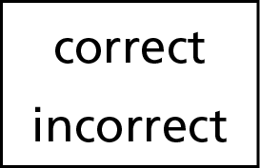 because he 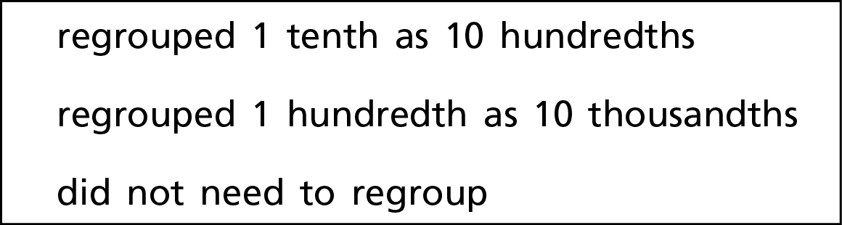 to subtract.
 Izzy hiked 5.252 kilometers, Laura hiked 4.214 kilometers, and Anna hiked
4.403 kilometers. How far did Izzy, Laura, and Anna hike in all?
______ kilometers

 Evaluate each expression. (hint- solve each and select your answer from the box)
815.674 + 511.551 =
491.386 + 865.849 =
687.193 + 640.022 =

 Larry writes this number sequence following a pattern.
2.56 , 3.84 , 5.12 , 6.4 , _______ Rule______________________
What is the next number and what is the rule?

 Miriam took $15.75 to the zoo. She bought 2 stuffed animals for $4 each, a
drink for $2.25, and animal stickers for $1.80. How much money does Miriam
have left now? (hint- multi step problem)
$ ______

